What, Where, When – Anchoring Knowledge In Time And Space

Abstract: This poster explores and demonstrates progress in the evolution of building a knowledge theatre/game environment. It will present in a 3D collage of how such an environment is being constructed. Embedded in the “poster” will be actual prototypes running on several tablets. This works focus has been primarily focused on children but is applicable to all learners.

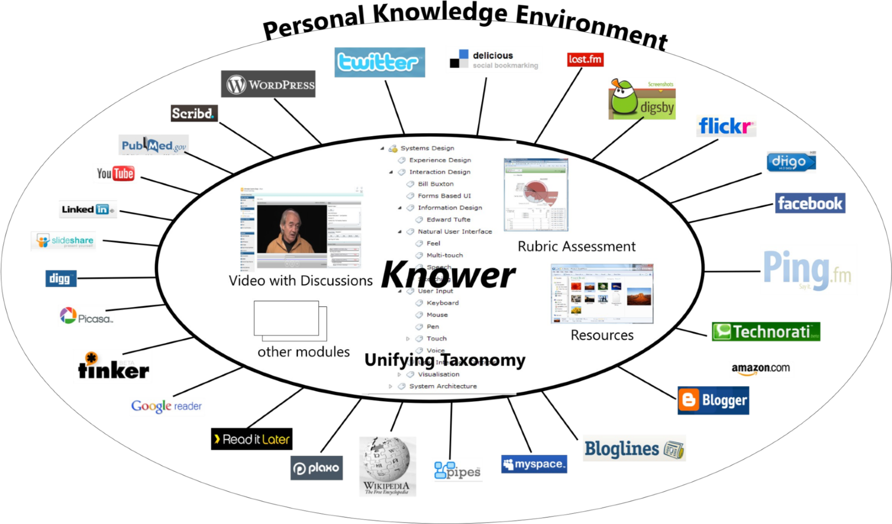
Figure 1. A Knower

Background

At EdMedia 2012 I presented a poster, “Making Information Coherent with a Personal Knowledge Integrator – A Knower”. The intent of this “poster” was to utilize the board and table space promised by the conference in a 3D collage, a physical prototype of this design. As it happened the resources were not as described by the conference and it had to be collapsed on to the pin-board in 2D. Nevertheless it was very successful in drawing comments and ideas which helped stimulate our last 3 years of work, building from large datasets presentations of knowledge in interactive visualizations and games. This “poster” then is presented to once again taking the next iterative bite of the conference attendees’ attention to guide the ongoing design.

What then is a Knower?

A Knower could certainly be described as a mash-up and has been by Clayton Costa [edtechpost 2008-2009]. In our lives data flows up and down the spokes of our attention from data sources and sinks, in and out of the mind. Because of the nature of the mind it is hard for us to correlate all that we are presented with thus limiting possible insight and understanding. The service a Knower can provide is to connect, coordinate and present this diverse data which may then be said to be better coalesced into knowledge in our minds. A Knower’s aim is to increase the value of the information wealth available but not generally digestible. It does this by using many techniques from AI and big data to amplify context and cross-reference in multi-dimensional graphs. A Knower consists of 3 elements, interfaces (pipes) to data sources and sinks, a data store/cache and, of course, many user interfaces. Figure 1. shows a functional sketch with examples of possible projections of the data into a variety of use cases.

The Taxonomy Model

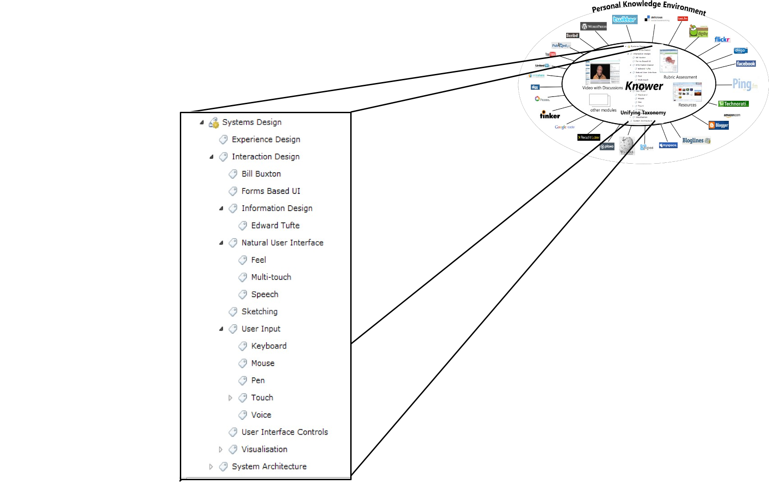.
Figure 2. Taxonomy Module of a Knower
The taxonomy of a subject is the “spine” of any teaching and learning process. The more that the pointers on the timeline of the Video Annotator and rubrics of the Rubric Assessor can be directly related to the subject area taxonomy, the more useful will each of these modules be. The taxonomy, indeed our language and its many relationships, provide the “spine” by which all resources, activities etc. in our learning are classified. Taxonomies are available commercially and in the public domain describing many subject areas. The most general taxonomy of all is our language which is available via WordNet [WordNet] and which is integrated into the current Knower prototypes.
“Knowledge was once an internal property of a person, and focus on the task at hand could be imposed externally but with the Internet, knowledge can be supplied externally but focus must be forced internally” [Stanger, L. 2010]

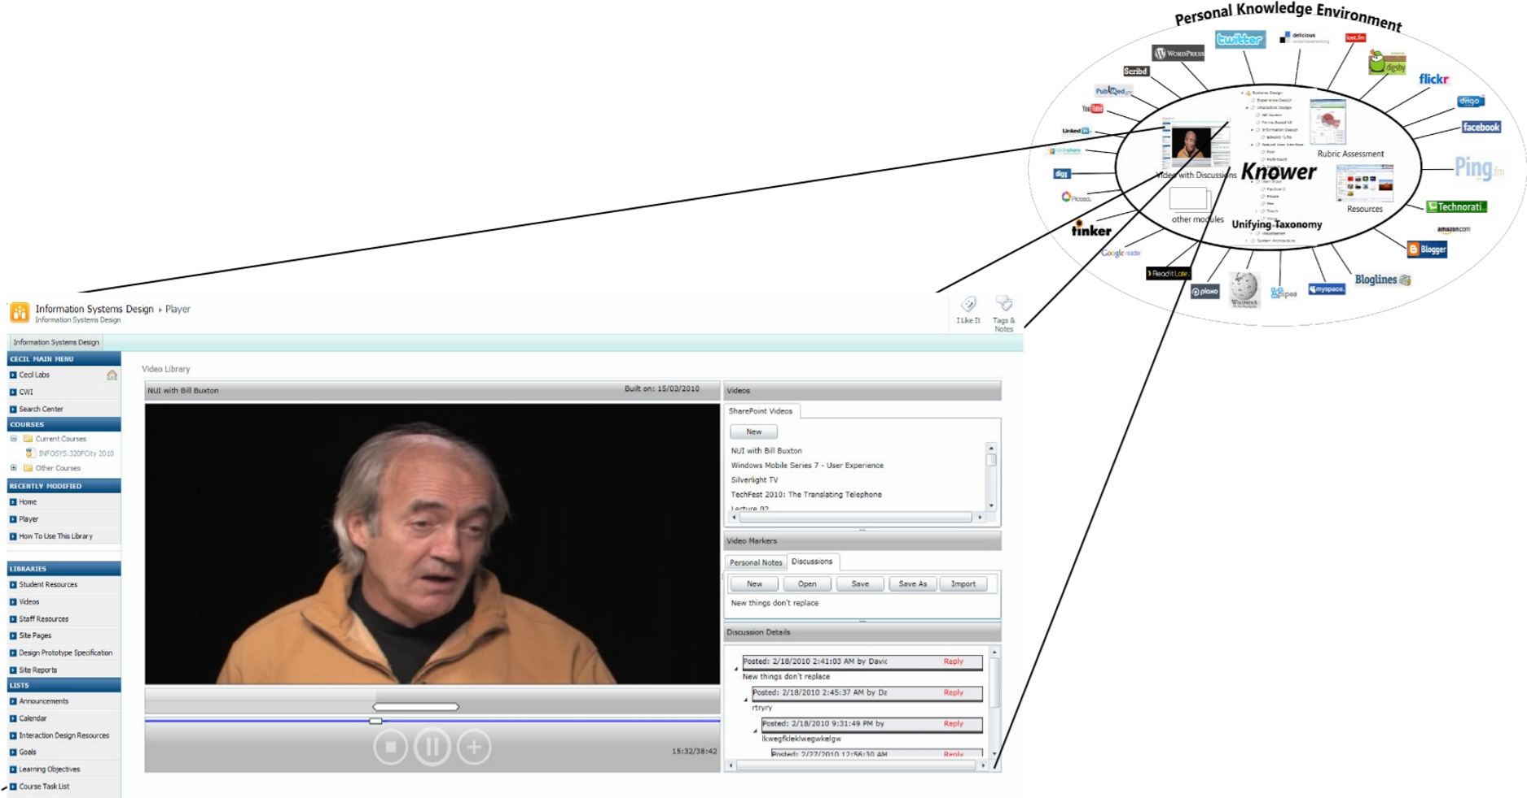
Figure 3. Video Annotator Module of a Knower
The Video Annotator (Fig. 2) is a module of a Knower which allows people to annotate videos for both personal and public use. Annotations are made by clicking the “+” button which places a marker (icon) at the video’s current position on the timeline. When annotated videos are linked to an online discussion, a public marker is placed on a discussion thread which is then displayed when the video plays or the marker selected on the timeline. As annotations are made they are automatically classified using a classification engine such as Pingar.

3D Visualization of Knower Data Flow

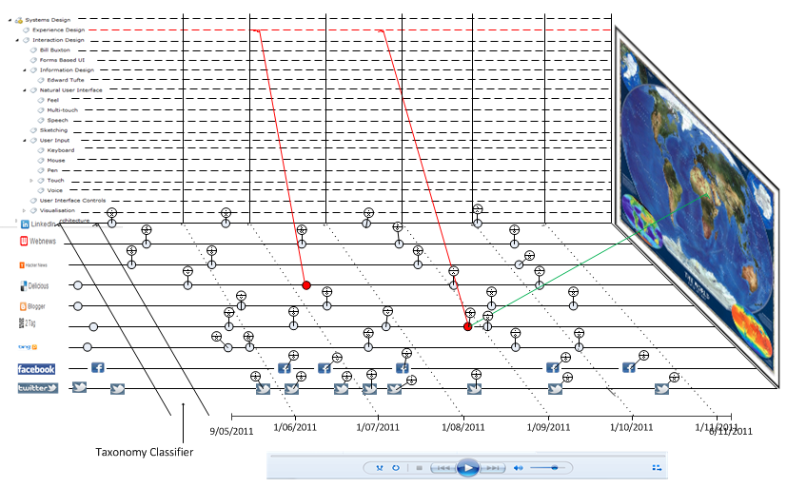

Figure 4. Knower Data Flow

The problem a Knower is attempting to solve is exposing the meta (higher) knowledge contained in the stream of information fragments such as emails, web pages, documents, twits, tags, and favourites etc. which pour towards us. It is proposed that this should be done by categorising these fragments both implicitly by search, and explicitly, automatically or manually, against our taxonomies of interest. Everybody shares, in a way, a common taxonomy of the world in general, albeit, in multiple languages. Cultural differences exist but there is huge overlap. A taxonomy is simply a model of a part of the world. In this case it is proposed that a relational dictionary, such as WordNet (WordNet, 2010), will provide the core taxonomy as a starting point for all people in whatever language they choose. This will then be augmented by personalised taxonomies which could be shared between other individuals and groups (Bieber, 2002). These taxonomies would be continually replicated across devices and clouds. Taxonomies can also be acquired from many sources describing aspects of the world from shoe-making to biology.
The need to “mine” un-structured data is a common theme in corporate systems but the individual generally carries out isolated tagging and filing based on separate applications. Services such as delicious.com provide a way to share such activities with others.
A vital requirement for inter-Knower communication is a common agreed data format. While this is a simple statement to make it is certainly not a simple goal to pursue.
Most people are continually involved in teaching and learning activities as part of everyday life. While a Knower should fulfil these needs, it should also aid and integrate more formal educational activities in the continuous flow of a person’s knowledge, learning and teaching.

2D Game

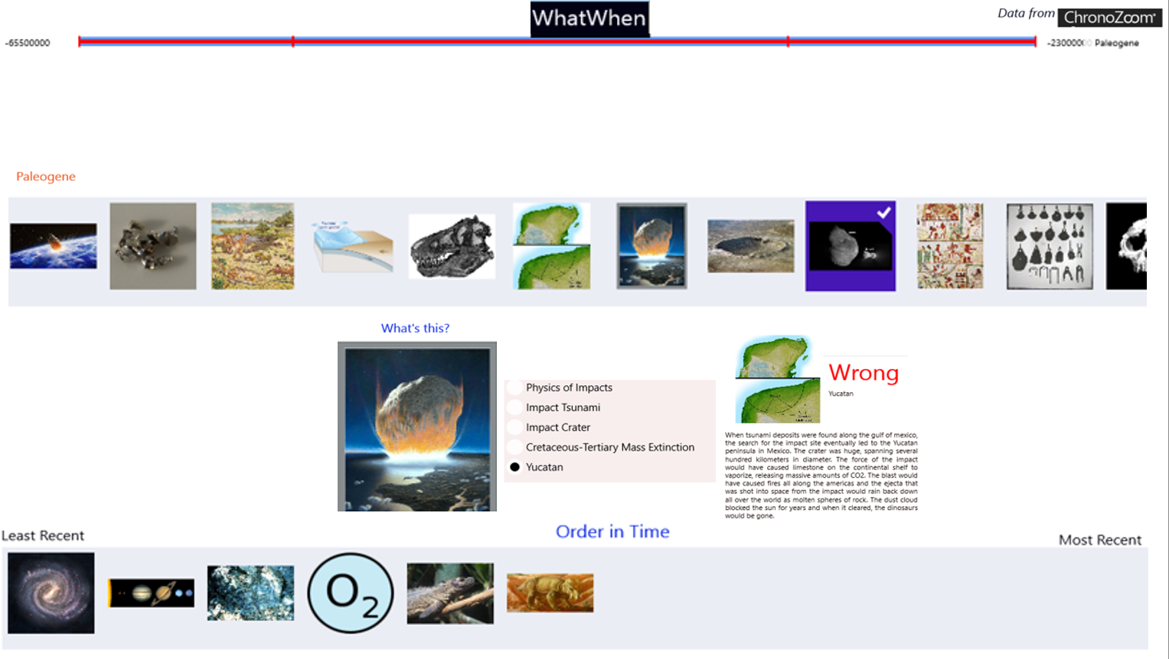
Figure 5. What, When (2D version)

The use of quizzes for both formative and summative assessment is well known but most of the time they are not seen as games. When we look at the rewards, leaderboards and other infrastructure of games, we can see a direct parallel with many teaching and learning activities including complete courses. There is much literature (Lee, J. J. & Hammer, J. 2011) on the gamification of education. Quizzes, however, are generally written by a person to test the knowledge of a domain. Given a description of a subject in a database, the data can be used to generate quizzes and other games. This work stretches back to, and takes up the challenges of, Augmenting the Human Intellect (Englebart, 1962).
This poster builds on the design for a knowledge theatre (White, 2010, 2011, 2012) which described placing knowledge on a ‘stage’ in a 3D projection so that it is seen in the context of other knowledge and then through juxtaposition, connections can be learned, reinforced and created. 3D worlds such as Second Life are also seeking to address these needs (Antonacci et al, 2008). The knowledge theatre focused on children and the initial subject area was the emergence of life. Many people struggle to conceive spans of time (Armstrong & Grafton, 2010) and the relationship of events. It is this cognitive challenge that the knowledge theatre seeks to illuminate.

As the design and construction of prototypes of a knowledge theatre were iteratively explored, it became clear that while visualization is powerful it is passive and limited in holding the attention of children (or any learner). Thus the emphasis moved from theatre to game. This type of game falls into the class of a serious game. Wikipedia defines a serious game as: “a game designed for a primary purpose other than pure entertainment. The "serious" adjective is generally appended to refer to products used by industries like defense, education, scientific exploration, health care, emergency management, city planning, engineering, religion, and politics”.
The game description of the serious game/quiz which follows is a game in the form of a contextual quiz designed to be either integrated into current Chronozoom interface or as a stand-alone UI connecting to the Chronozoom data. The reason for designing a quiz as an initial attempt to create a contextually rich interactive experience was that the data contained in the current beta version of Chronozoom does not provide the structure of data required for a more animated game. However this design is a good illustration of how a contextual quiz supported by data about the subject of focus can be used to engage the learner.
This serious game/contextual quiz has been built and playing with this and other prototypes has been found to be very engaging for learners of all ages. This iterative prototyping is continuing and will lead to detailed studies of the effectiveness of such data based educational resources.

Chronozoom 3D Interactive - A Foundation for Exploration and Gamification

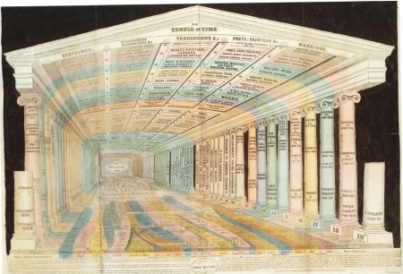

Figure 6. The Temple of Time, Emma Willard, 1846
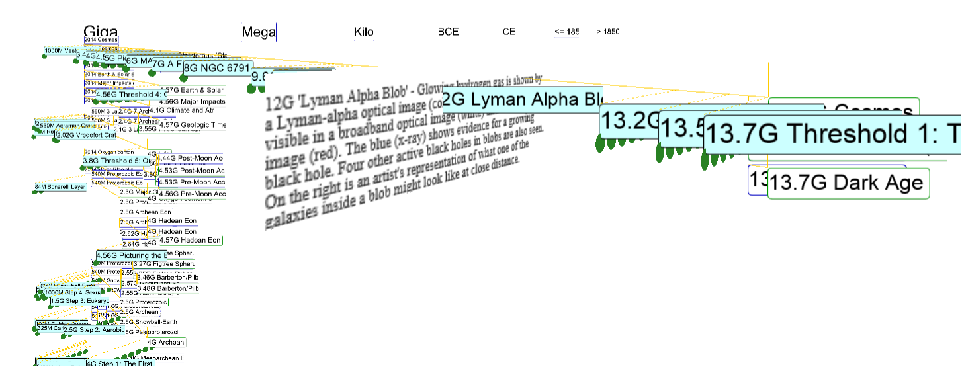
Figure 7. 3D Game Space with Pan, Zoom and Fly

The primary motivation for this work is to increase the context of the data presented and the visceral feeling of the time-space, the “zoomability”, and thereby increasing engagement. Chronozoom 3D will be used to create games that engage motor skills, using game controllers and Kinect to fly and jump. This will action focus will make learning more effective in comparison to the passive nature of ChronoZoom beta.
A minimalist design approach has been followed to allow high information density and strong context with progressive revelation of detail through filtering and navigation. Event dates create implicit scales. By showing all elements in one view, context is continuous.
The initial display shows one “scale set” with one timeline and its events and artifacts. Dots are clickable, acting as placeholders for artifact images. They reveal the artifacts’ titles and descriptions (truncation of labels is a bug!). “Scale sets” such as the Eight Thresholds of Big History will be user configurable. sub-timelines are placed vertically in the order of recursive retrieval but many other arrangements are possible. The current vertical layout algorithm is primitive.

Conclusion
This sequence of prototypes will be presented to stimulate discussion and provide input into current and future work.

References

Anh Tuan Tran, Elbassuoni S. & Preda N. & Weikum G. (2011) CATE: Context-ware timeline for entity illustration, Proceedings of the 20th International Conference Companion on World Wide Web (WWW 2011), Hyderabad, India, 269-272

Antonacci, D. M. & Modaress, N. (2008) Envisioning the Educational Possibilities of User-Created Virtual Worlds, AACE Journal, vol. 16, no. 2, pp. 115–126

Armstrong D. & Grafton A. (2010) Cartographies of Time, Princeton Architecture Press

Christian D. (2011) Maps of Time: An Introduction to Big History, California World History Library

Chronozoom (2012) http://www.chronozoomproject.org/#/t55

Engelbart D. C. (1962). Augmenting Human Intellect: A Conceptual Framework. SRI Summary Report AFOSR-3223. Prepared for: Director of Information Sciences, Air Force Office of Scientific Research

Geonames, Geonames.org

Hoffart, J. & Suchanek, F. M. & Berberich, K. & Kelham, E. L. & Melo, G. de & Weikum, G. (2011). YAGO2: Exploring and Querying World Knowledge in Time, Space, Context, and Many Languages Demo paper in the proceedings of the 20th International World Wide Web Conference (WWW 2011) Hyderabad, India

Kay A. (1987). Doing with Images Makes Symbols: Communicating with Computers, http://www.archive.org/details/AlanKeyD1987

Lee, J. J. & Hammer, J. (2011). Gamification in Education: What, How, Why Bother? Academic Exchange Quarterly, 15(2).

Merrill M. D. (2002) Knowledge Objects and Mental Models, Educational Technology Research and Development, 50(3), 43-59

Miller G. A. (1995). WordNet: A Lexical Database for English, Communications of the ACM Vol. 38, No. 11: 39-41

Nelson T. (1987) Computer Lib/Dream Machines, Tempus Books of Microsoft Press, ISBN 0-914845-49-7

Tufte E. R. (1990). Envisioning Information, Graphics Press

Uren V. Cimiano P. & Iria J., Handschuh S. & Vargas-Vera M. & Motta E. & Ciravegna F. (2006). Semantic annotation for knowledge management: Requirements and a survey of the state of the art, Journal of Web Semantics

White, D. C. (2010). Design and Implementation of a Personal Knowledge Integrator Federated with Personal Learning Environments, Proc. Personal Learning Environments 2010

White, D.C. UX, (2011). Data and Non-Functional Architectural Design Considerations for Personal Knowledge Integrators, Proc. Personal Learning Environments 2011

White D.C. (2011). Making Information Coherent with a Personal Knowledge Integrator – A Knower,
EdMedia 2011

White, D.C. (2012). Architecting a Knowledge Theatre, Proc. ICEIT Conference Proceedings

White D.C. (2014). Turning Data to Knowledge with Serious Games and Contextual Quizzes EdMedia 2014

