2012
Considerations for Architecting a Knowledge Theatre

David C. White
Information Systems and Operations Management Dept.
The University of Auckland
Auckland, New Zealand
d.white@auckland.ac.nz

Abstract—This paper describes the architectural design considerations for building a new class of application, a Personal Knowledge Integrator, a Knowledge Theatre or Knower. It then supports this description by describing a scenario of a child acquiring knowledge and how this process could be augmented by the proposed architecture and design of a Knowledge Theatre.
Knowledge; personal; open data; visualization; learning; teaching;

Introduction
What I hear, I forget,
What I see, I remember,
What I do, I understand [30]
This paper builds on the concepts and designs in [4] and [5] in which I introduce the concept of an application class of type Personal Knowledge Integrator which I call a Knower. It then describes the design of an evolving instance of a Knower, Noah. For clarity, within this paper I am referring to Knowers as Knowledge Theatres. The intent of this paper is to record the work in progress in the hope that others will build applications of this class and that we are all able to coordinate our knowledge over agreed standards. From an extreme viewpoint, I see this work as a potential re-envisioning of the computer interface. While Microsoft, in Windows 8, have this same goal and their metro style is interesting, it is still floating over metaphors of files and apps. Here I suggest we start with a backdrop of the facts of the world in which files and apps play secondary roles.
This design is aimed to be usable by a child, the learner in all of us, to acquire and construct their knowledge over the background of the knowledge of humanity.
Files and apps are still present but in the ever present context of time, space and knowledge. One of the principles of the Microsoft metro design language is to be authentically digital. I extend this to mean authentically digital, embracing 3/4D with a direct relation to games, the play. The knowledge theatre seeks to be a place to explore the play of life. Augmented reality already merges a model of the world with reality. Persuasive technology [27] could also be used in such a setting drawing on the knowledge base to put the “facts on the table” when seeking to persuade and influence.
The theme of the ICALT 2012 conference is in itself calling for such a design and I have reworded the conference title and description to embrace this.
Growing through learning
- by architecting a knowledge theatre
- on top of our memories, our stories, the facts we, ourselves, our groups, humanity know about the world
- linking, acting out performances of objects and events in space, time and context as simulations
with design inspired learning, fostering
- creativity and fun,
- complex or simple educational experiences and their monitoring,
- ubiquitous learning and flexible environments in a knowledge theatre, a place of playfulness.
The problem the knowledge theatre is attempting to solve is placing knowledge on a stage so that it is seen in the context of other knowledge so that through juxtaposition, connections can be reinforced and created.
People are continually involved in teaching and learning activities as part of everyday life. While a knowledge theatre should fulfill these needs, it should also aid and integrate more formal educational activities in the continuous flow of a person’s informal learning and the knowledge focussed activities of learning and teaching. It is against this background that this paper describes the requirements for a knowledge theatre, and explores, with a focus on the architecture of user experience and data, the work being carried out towards the creation of a general design of a knowledge theatre and a particular instance, Noah.

usage Scenarios
Scenarios describing how a classic teacher/student interaction, an old grandfather, a young artist, a history teacher and an environmental group all have a need for a knowledge theatre and were described in [5]. However, the most important scenario, the child, was omitted. This is the most important because it is where we all begin our paths of knowledge discovery and where it is possible to apply the levers of technology to maximum effect. For a start we should follow the maxim of Alan Kay [13] and “design for children” to produce the best design for everyone. And why not begin the “Augmentation of the Human Intellect” as described by Douglas Engelbart [14] as early in life as possible. In the early 1970’s a huge computer room at Victoria University, New Zealand housed one B6700 computer. On the wall hung a tapestry created by Robert M. Gordon with the prophetic words “A computer is a device for storing knowledge in directly usable form”
It is with these directives from past visionaries that we can see the need to re-imagine the computer, the device, which will accompany a child while growing to an adult and on through life. If we were designing a digital space to support the acquisition of knowledge, would it look like iOS, Windows or Linux which are 30 year old shells over layers of abstraction of hardware? No, we would design an environment for immersive actionable knowledge. Would we not make a model of the world the primary interface? The child, the learner, could then explore, experience and be enlightened continuously. So that, slowly, their paths of experience are lit up against a backdrop of humanity’s knowledge.
The name of Shakespeare’s theatre, The Globe, where his plays, which sought to illuminate the condition of mankind, were performed also inspires these architectural design considerations.
Knowledge comes in many different forms and the initial proposed knowledge theatre only addresses a small segment of these. However it does always situate knowledge in time, space and context as proposed in [1] and [5].

The Child
First let us imagine a child in a typical household in a first world country. This is of course a privileged child but we would all hope that all children one day will be in this position and have a similar learning environment.
The child will have books. Maybe they will have a book about birds of the country in which they live. They may also have a book about dinosaurs, which always seem to inspire a deep interest, even though from another time and place. So these books, and they could be e-books, are presenting disconnected fragments of knowledge in text and images.
The child is then taken to visit an aquarium where there are fish and lizards and other creatures, and then to a museum in which they see extinct animal skeletons from a distant time and place exhibited. The child, the learner, is not presented with the connections between all these pieces of knowledge. Of course, the child is making the connections themselves. As referred to in [23] “learning is promoted when learners integrate their new knowledge into their everyday world” and we can aid this by presenting and maintaining these connections in a clear structured way.
For example we may try today to create connections for a child, in a physical sense, with a globe or a map so as they travel or learn new things these can be placed in a geographical context. This is really only transitory connection as the map exists separately from all the other knowledge fragments. Imagine if the globe/map were available to the child all the time and that they could plot their acquisition of knowledge onto it continuously and retain it forever using whatever device they had at hand. This is the intent of a knowledge theater. One could also call this a knowledge scrapbook which supports “inter-twingling” [31]. Also the existing knowledge of humanity would always be available, flickering from the shadows filtered through appropriate lenses based on the understanding of the learner.
After 3D space the other primary dimension of our world is time. I personally, and I observe that others also, have great difficulty positioning events in relation to each other whether it is near history or the evolution of the universe and life. We may learn facts of history but our sense of time and the sequence of events is very weak. While maps/globes allow us to build a mental model of at least the earth (though space is more difficult) seeing and recalling relative events in time are much more challenging.
It is this clear sequence and juxtaposition of knowledge which leads to understanding of cause and effect. To provide an environment for children has the potential to enhance and deepen understanding.
The descriptions of the history of timelines in [15] shows us how humans have struggled to solve this problem over the last few hundred years and on the web we can find many examples [24], [25].
The challenge then is to design a timeline which a child could use.
As children learn they are constructing their personal taxonomy so they should be able to see the linkages between classes such as animals, birds, dinosaurs and people. Even though they know only a portion of the knowledge of the world they should be able to have readily available to them the “complete knowledge” of man so associations can be floated into their minds.
They may be travelling across the Badlands, South Dakota, reading of dinosaurs in an e-book which could then, using GPS, illuminate their current reading with knowledge about that place but in another time when dinosaurs roamed as well as showing the fossils they may find in the present.
Naturally children learn instinctively the principles of generalization and specialization as they acquire language but even as adults we have very weak maps of the structure of the world and the knowledge that describes it. Lighting up appropriately filtered taxonomies in simple visualisations could aid in understanding the structure of the world.
The emphasis of the knowledge theatre design is to facilitate the creation of rich and continually reinforced structure in the learner’s mind by playing out the facts in the knowledge theatre. David Merrill [23] has said “the greatest impact on learning results from the representation and organization of the knowledge to be learned”.

Dimensions of a Knowledge Theatre

Space – Dimensions 1,2,3
Space is the most easily represented dimension as it is where we live. We are familiar with abstract representations in 2D as maps and 3D as globes. Also Google Earth and Microsoft Virtual Earth are available to all. Within a knowledge theatre, multiple views utilising these elements will be available to the knowledge explorer.

Time - Dimension 4
Many people over the centuries have grappled with how to represent time. A modern tool such the Microsoft Project Manager fails to deal with a requirement for multiple and non-linear views of time. This area is an on-going focus of this design and in Fig.1, a possible multi-scale timeline shown based on a timeline for a science fiction novel [15, 29].
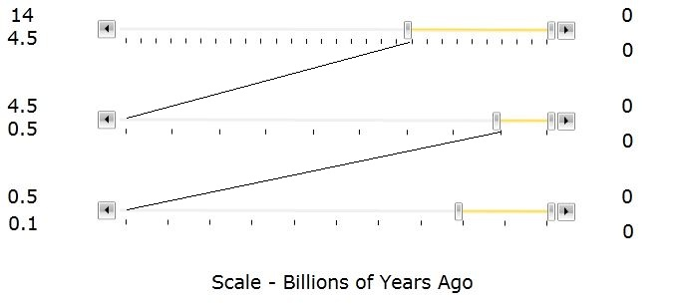
Fig. 1 Multi-scale Timelines
This multi-scale timeline allows time to be referenced across its vastness with all the scales changeable but moving dependant on the others. The right-hand ends represent the present and the future would be farther to the right but is not shown here for simplicity. To span from the age of the universe to a day or a second would require about 10+ scale timelines compared to the three shown above.

Knowledge - Dimension 5
Is knowledge the 5th dimension? I will not pursue the philosophical or possibly spiritual aspect of this question here but in the design of the knowledge theatre we can think of it as such.
Everybody shares, in a way, a common taxonomy of the world in general, albeit, in multiple languages. Cultural differences exist but there is huge overlap. A taxonomy is simply a model of a part of the world. An example of this is a relational dictionary, such as WordNet (WordNet, 2010), which can provide a core taxonomy as a starting point for all people in whatever language they choose. This can then be augmented by personalised taxonomies which could be shared between other individuals and groups. These taxonomies would be continually replicated across devices and clouds. Taxonomies can also be acquired from many sources describing aspects of the world, from say shoe-making to biology.
Thus this next dimension on which the Knowledge Theater focuses is the structure of knowledge as provided in data sets such as WordNet[6], YAGO2[1] and other ontologies. It can be said that the classes of everything are defined within the dictionary of any language. Wordnet, a subset of YAGO2, is a computer readable example of this and is readily available.
The primary source of knowledge for this knowledge theatre is YAGO2 which is a knowledge base synthesised from Wikipedia, WordNet and GeoNames containing 80 million facts about the world.
The need to “mine” un-structured data is a common theme in corporate systems but the individual generally carries out isolated tagging and filing based on separate applications. Services such as delicious.com provide a way to share such activities with others. A vital requirement for inter-knowledge theatre communication is a common agreed data format. While this is a simple statement to make, it is certainly not a simple goal to pursue.
Some instances of classes (FACTS in the Yago2 sense) can also be found in a dictionary but in general are not.
Instances are the intersection of class and time and their activities represented by verbs.

User Experience

Information and Knowledge
However much you study you cannot know without action.
A donkey laden with books is neither an intellectual nor a wise man.
Empty of essence, what learning has he –
Whether upon him is firewood or book?
Saadi of Shiraz (13th Century)

Action Learning in the Knowledge Theatre
Through action and immersion in a knowledge theatre, it is intended to create an experience where “Learning occurs when attention is focused [28]”
The essence of the design of the user experience is illustrated in Fig. 1 which places a map, a timeline and a knowledge map, tree or network, on three planes in a 3D space. These are linked with connectors to show objects interacting through events. On the connectors can be placed the images, text and 3D objects which are associated with an event. These images, text and 3D objects are files and apps which dominate current user experience in contrast to a knowledge theatre where they illustrate in context. The sketches in Fig. 2 [34] and Fig. 3 further illustrate other views of the play.
This design has been guided by the Edward Tufte’s “Streams of Story” [16] in which he shows how the core of language, verbs and nouns, plotted in 3D against time makes up the stories of objects and events, the histories of existence, real and imagined, fact or fiction.

Physical Protoyping
In preparation for a poster session [19] illustrating the concept of a knowledge theatre, then referred to as a knowledge theatre, a physical 3D prototype was created. This was enormously helpful in that sketching physically in 3D was fast and easy. It also showed how one could create a 3D knowledge theatre for children, simply using a few sheets of cardboard, even before they approached a computer. It was also proven to be easily accessible to the poster audience. At the same time, it became clear that it would be possible to connect the physical world with the digital using a 3D sensing device such as the Microsoft Kinect [20]. This would provide an important bridge for young children from a physical to an abstract mentality.
After a child has constructed physical maps of time, space and knowledge the constructed scene can be mapped by the KINECT into digital 3D space.

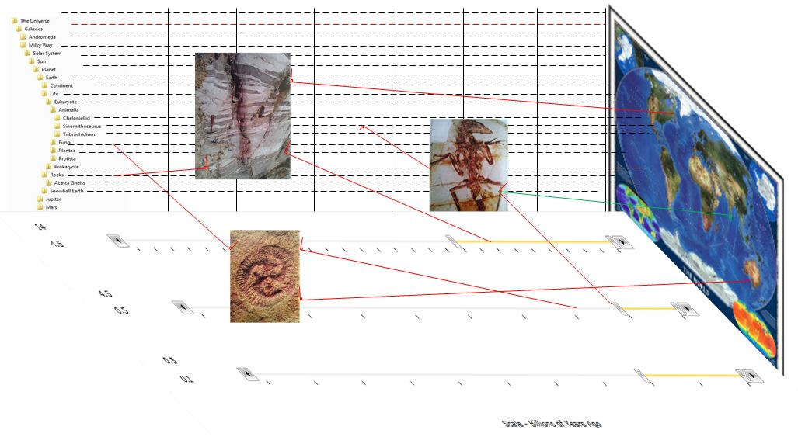
Figure 1. Theatre with 3 planes, space, time and knowledge
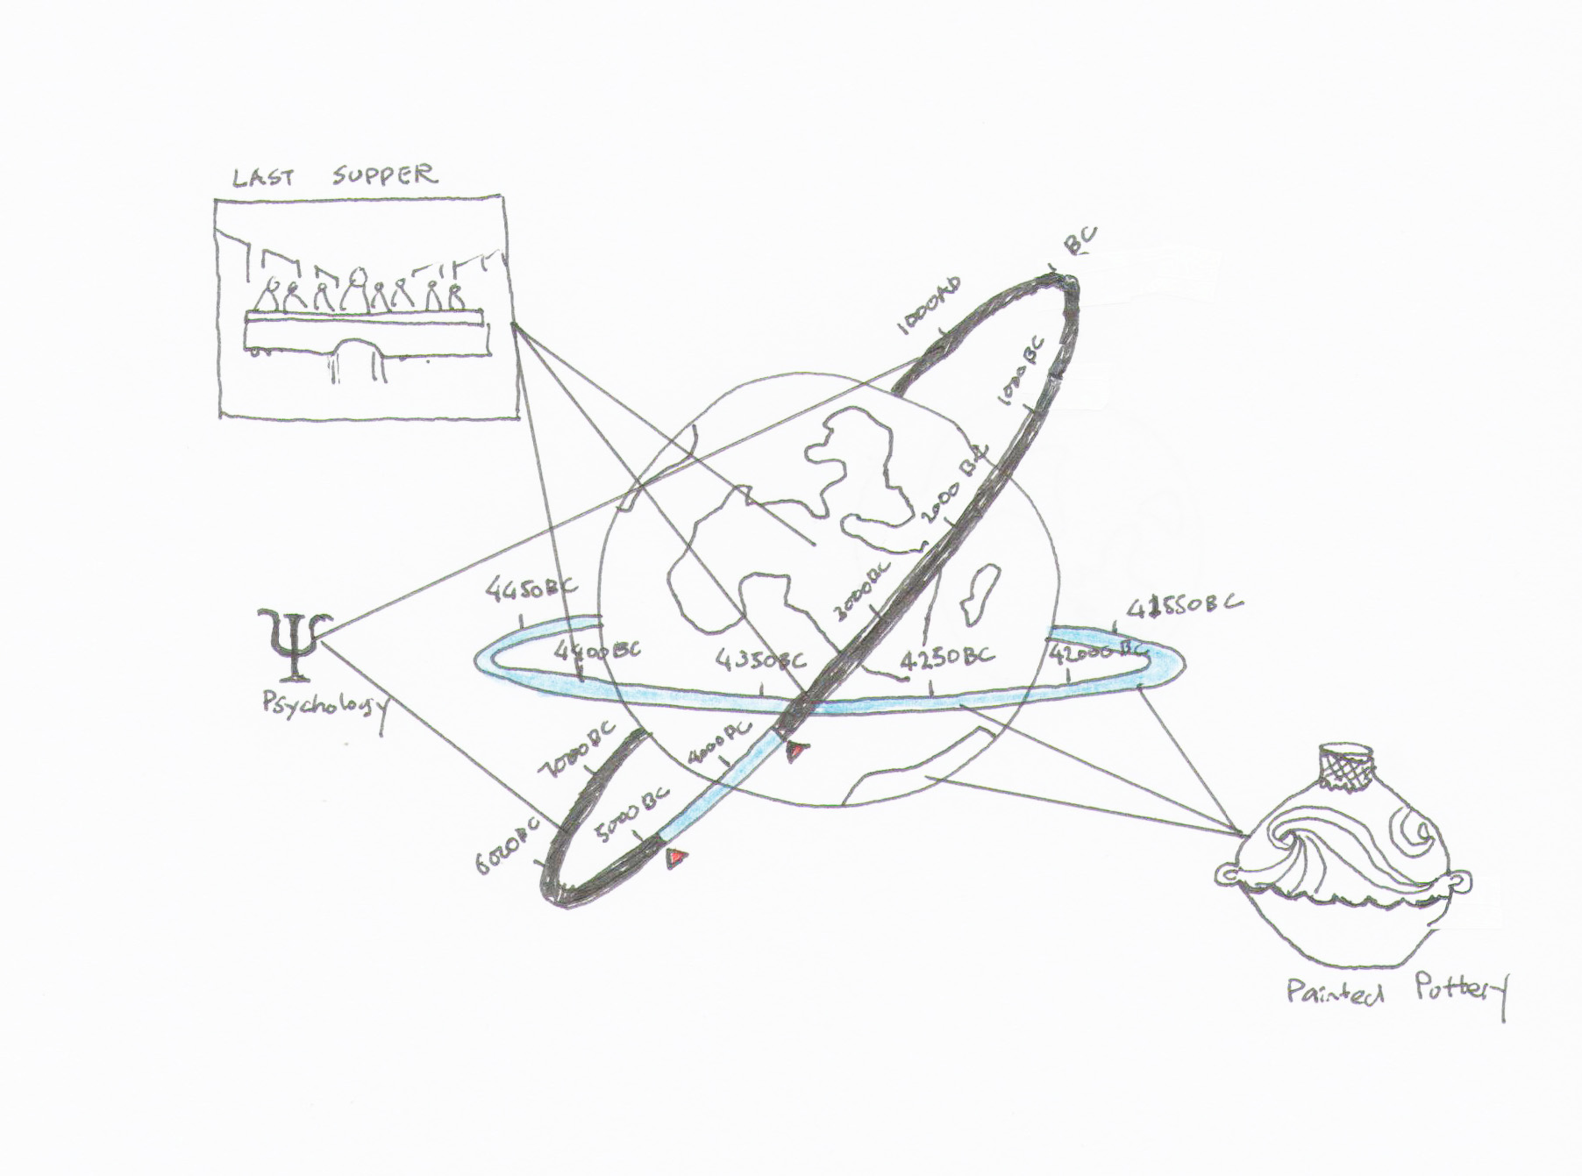
Figure 2. Globe with Rings of Time [34]
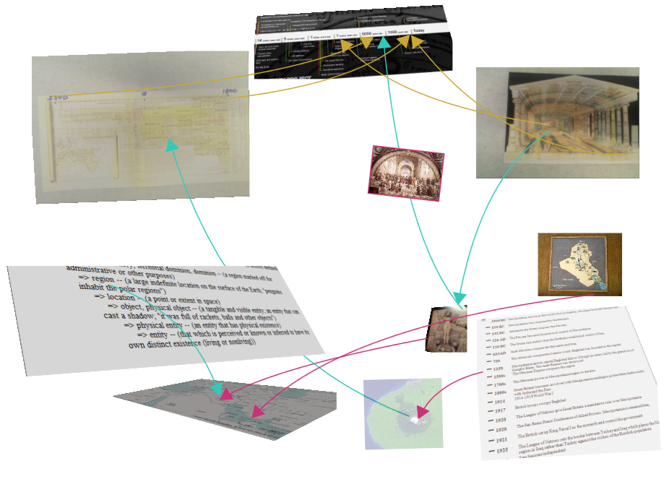
Figure 3. Theatre with Multiple Space and Timeline Planes

Sources of Knowledge/ Data
To provide a background tapestry of knowledge to the learner, many sets of data are required. A fundamental core would include the timelines of the geological history of the earth, man’s activities on earth and the taxonomical history of species past and present. Finding these in a simple accessible form has proven to be a remarkably hard task. It is possible to get lists as text in files and web pages but each one must be processed individually before being imported into a database of some sort so that all the facts can easily be queried and added to. This difficulty identifies two issues concerning data availability. In general, the specialist ‘owners/custodians’ of such data have not considered making it easily accessible to lay people outside their field. Secondly, the “web of data” [32] including the semantic web [33] is just “coming alive". This is happening very quickly so it won’t be long before this is not a problem and knowledge theatres will have many accessible backdrops.
YAGO2’s set of 80 million facts of the form subject, predicate and object, is being used as a starting point. It is derived from data in Wikipedia, the words, their meanings and their relationships from WORDNET and place names from GeoNames.
This problem of data sourcing has, and is being, addressed by Wolfram-Alpha [26] and it is hoped that their data can be used by knowledge theatres in the future.
There are many other potential sources of data from both private and public sources like,
- Jeremy Norman’s History of Science [24]
- Jeremy Norman’s From Cave Painting to the Internet [25]
- The Worldwide Museum of Natural History [11]
- A Decade of Discovery [10]
In the future it is hoped that access to datasets will become much easier, thus enriching the many knowledge theatres to be built.

First Principles of Instruction

The knowledge theatre seeks to bring alive the following five principles of instruction identified by David Merrill [23].

“The demonstration principle: Learning is promoted when learners observe a demonstration” - from juxtaposition and simulation.

“The application principle: Learning is promoted when learners apply the new knowledge“ - from recording and weaving own and new knowledge into a theatre’s backdrops.

“The task-centered principle: Learning is promoted when learners engage in a task-centered instructional strategy“ - from conscious research and acquisition.

“The activation principle: Learning is promoted when learners activate relevant prior knowledge or experience” – from juxtaposition when knowledge in one field intersects with that in another on one or more dimensions.

“The integration principle: Learning is promoted when learners integrate their new knowledge into their everyday world.” – by recording knowledge acquired which is continuously integrated with that which underpins the knowledge theatre.

Future Work
Now that a source of facts has been identified and imported into a database, work is continuing to create the interactions and visualisations discussed in this paper.
On a personal note, I have found that posting links and notes into a blog rapukemonna.wordpress.com and classifying them against my personal taxonomy of interest is laying the foundation for my future knowledge theatre.
Our personal taxonomies are our knowledge fingerprints.

Conclusions
There exists huge potential to use the inter-connected “facts” of humanity to create knowledge theatres, knowledge theatres in which a child’s - indeed any person’s – learning can be enriched and enhanced, delivering on the vision of Robert M. Gordon to “make knowledge available in directly usable form”.

References
- J. Hoffart, F. M. Suchanek, K. Berberich, E. L. Kelham, G. de Melo, and G. Weikum “YAGO2: Exploring and Querying World Knowledge in Time, Space, Context, and Many Languages” Demo paper in the proceedings of the 20th International World Wide Web Conference (WWW 2011)
- Hyderabad, India, 2011V. Uren, P. Cimiano, J. Iria, S. Handschuh, M. Vargas-Vera, E. Motta, F. Ciravegna, “Semantic annotation for knowledge management: Requirements and a survey of the state of the art”, Journal of Web Semantics, 2006
- ODATA, Open Data Protocol, www.odata.org/
- D. C. White, “Design and Implementation of a Personal Knowledge Integrator Federated with Personal Learning Environments”, Proc. Personal Learning Environments 2010, 2010
- D. C. White, “UX, Data and Non-Functional Architectural Design Considerations for Personal Knowledge Integrators”, Proc. Personal Learning Environments 2011, 2011
- G. A. Miller,. “WordNet: A Lexical Database for English”, Communications of the ACM Vol. 38, No. 11: 39-41, 1995
- L. Stanger, “Individual Knowledge in the Internet. Educause Review” March/April 2010, p.16., 2010
- E. R. Tufte, Envisioning Information, Graphics Press, 1990
- S. Pepper, The Tao of Topic Maps. Infostream, 2002
- A Decade of Discovery, http://www.coml.org/
- Worldwide Museum of Natural History, http://www.wmnh.com/
- Microsoft Kinect used to map asteroids, glaciers, other scary things, http://www.engadget.com/2011/12/15/microsoft-kinect-used-to-map-asteroids-glaciers-other-scary-th/
- A. Kay, “Doing with Images Makes Symbols: Communicating with Computers”, http://www.archive.org/details/AlanKeyD1987, 1987
- D. C. Engelbart (October). "Augmenting Human Intellect: A Conceptual Framework". SRI Summary Report AFOSR-3223. Prepared for: Director of Information Sciences, Air Force Office of Scientific Research, 1962
- D.Armstrong, A. Grafton,, “Cartographies of Time”, Princeton Architecture Press, 2010
- E. Tufte, Visual Explanations, Graphics Press
- Open Data Protocol (OData), http://www.odata.org/
- Windows Azure Datamarket, https://datamarket.azure.com/
- D. C. White, “Making Information coherent with a Personal Knowledge Integrator – a Knower”, Ed-Media 2012, Outstanding Poster Award, 2012
- Microsoft Kinect, http://www.xbox.com/en-US/kinect
- NoahAKnower Blog, NoahAKnower.wordpress.com
- D. Palmer, Earth in 100 Groundbreaking Discoveries, Quercus, 2011
- M. D. Merrill, “Knowledge Objects and Mental Models”, Educational Technology Research and Development, 50(3), 43-59, 2002
- Jeremy Norman’s History of Science, http://www.historyofscience.com/
- Jeremy Norman’s fron Cave Painting to the Internet, http://www.historyofinformation.com/
- Wolfram-Alpha, http://www.wolframalpha.com/
- The Stanford Persuasive Technology Lab http://captology.stanford.edu/
- Radner and Rothschild, 1975; Winter, 1981
- O. Stapleton, “Last and First Men: A Story of the Near and Far Future”. London: Methuen, 1930.
- Lao Tse, “The Te-Tao Ching”, born 603 BC
- T. Nelson, “Computer Lib/Dream Machines”, Tempus Books of Microsoft Press, ISBN 0-914845-49-7, 1987
- ReadWriteWeb, http://www.readwriteweb.com/archives/web_of_data_machine_accessible_information.php
- Semantic Web, http://semanticweb.org/wiki/Main_Page
- J. Lee, 2012

