2010
Design and Implementation of a Personal Knowledge Integrator Federated with Personal Knowledge Environments
David C. White, The University of Auckland, New Zealand
d.white@auckland.ac.nz

Abstract
This paper introduces the term Personal Knowledge Environment as a generalisation from Personal Learning Environment. It then introduces the term Personal Knowledge Integrator and describes a design science (Nunamaker 1991) approach to the design, implementation and evaluation of a framework for an instance of a modular Personal Knowledge Integrator utilizing a Microsoft Silverlight Rich Internet Application (RIA) working across multiple platforms including PC’s and mobile phones extending and synchronising with a federation of Learning Management Systems, Personal Learning Environments and other sources and sinks of information.

1. Background
In 1995 The University of Auckland, New Zealand, built and deployed the world’s first web-based Learning Management System – Cecil (derived from CSL, Computer Supported Learning [Gardner, L., 2002]). Cecil has evolved continuously over the past 15 years and currently supports 42,000 logins/day and is used by 73% of the courses and 96% of students (~40,000) at the university. As it evolved the Cecil designers have seen the advantage to both students and teachers of having a more decentralised approach to computer supported learning. This desire for decentralisation was motivated at first by a need to minimize, using synchronisation, a person’s time required to upload and download resources and to minimise the need for network connectivity while still supporting collaboration. It is now seen more in the context of providing a continuous integration point for a person’s knowledge, learning and teaching.
For some time it has been recognised that the ability to expand the functionality of Cecil was being limited by an old codebase and especially the availability of developers with appropriate skills to change and maintain it. Various other LMS’s (SakaiTM, MoodleTM etc.) were examined as potential replacements but were recognised as having similar architectures to Cecil including the same large codebases of now commonly available ”out-of –the-box” functionality.
An LMS is, at its core, a collaborative knowledge management system with the addition of various specialised tools such as grade books and testing tools. So a study of such systems was made and Microsoft SharePointTM selected as the way forward to provide the foundation for computer supported learning which would also provide an integrated platform for administration and research. Our use of SharePoint began in 2002, as one of the pioneer sites, and in the last two years a small number of courses have used SharePoint 2007 in conjunction with and integrated into Cecil. SharePoint provides a bridge to extend the functionality of Cecil while other embedded modules, features and functions such as the Cecil Gradebook will continue to be used.
SharePoint 2010TM is currently being deployed and will be the foundation for the provision of centralised computer supported learning - Cecil:2010. Cecil, Moodle and other systems will be federated through Cecil:2010. The name SharePoint, when separated from the brand speaks of an infrastructure which allows the creation of Points (sites) at which resources from many sources can be Shared and collaboration is implicit in its design.
It is against this background that this paper defines a component of a PLE, the Personal Knowledge Integrator, and describes the work being carried out towards the creation of a particular instance.
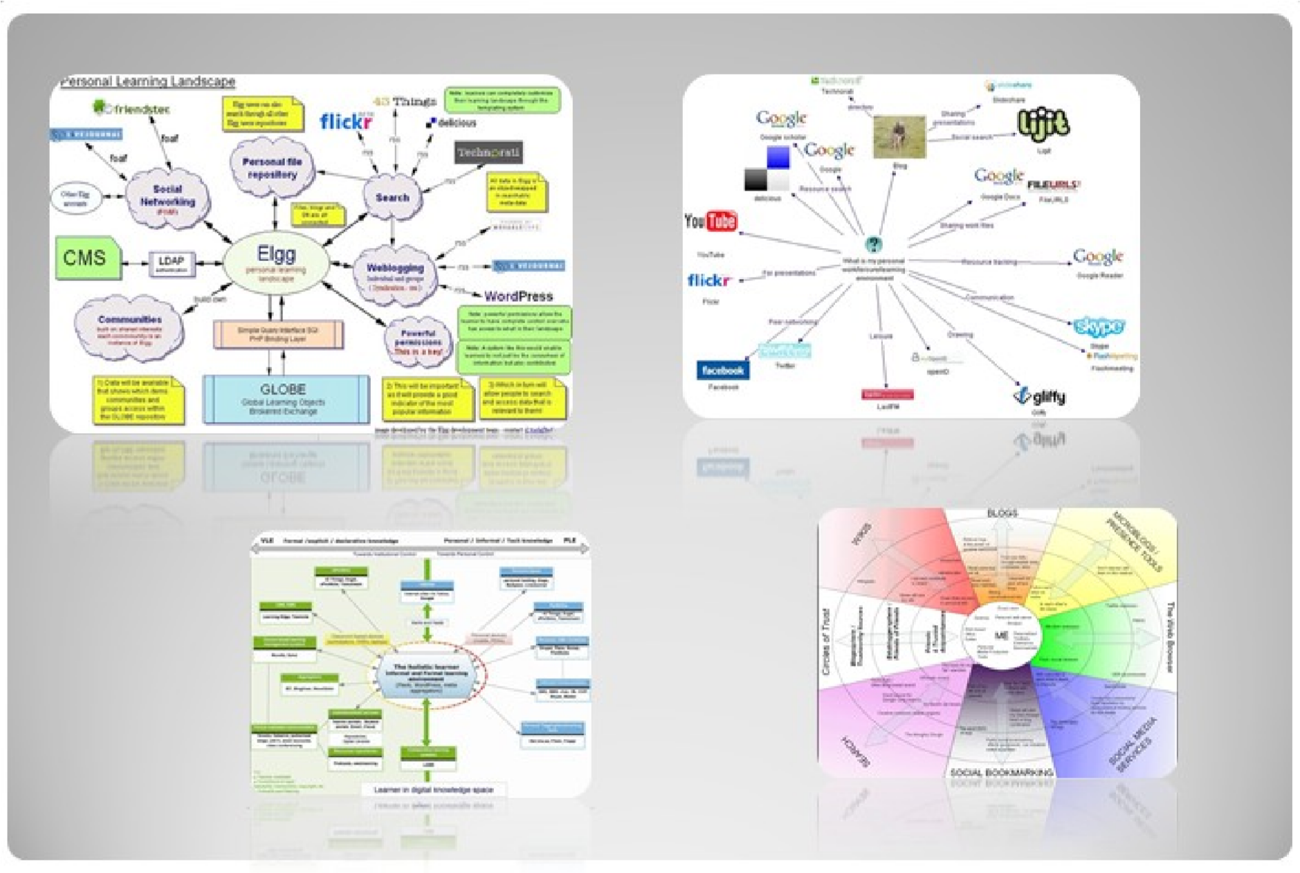
Fig.1 Sample examples of Personal Learning Environments
2. From Personal Learning Environment to Personal Knowledge Integrator Since the introduction of the term Personal Learning Environment there have been many attempts to define it. I will begin with the definition given in “7 things” [Educause 2009].
“The term Personal Learning Environment (PLE) describes the tools, communities and services that constitute the individual educational platforms learners use to direct their own learning and pursue educational goals”.
While examining the wonderful collection of PLE diagrams [edtechpost 2008-2009], some of which are shown in Fig. 1, I was struck by the fact that, though drawn as PLE’s, I saw them also as PTE’s -Personal Teaching Environment’s. We are all learners and some, though maybe all, are teachers. People are in different roles at different times and situations. These Personal Environments are the same for both learners and teachers. So the term for this more general class of Personal Environment that I will use in this paper is a Personal Knowledge Environment (PKE).
At this point I should reveal my bias. As well as being a teacher, learner, seeker and accumulator of knowledge, I am a software designer/developer.So when confronted with the term PLE my compulsion was to design and build one. Almost all the diagrams in “collection of PLE diagrams” [edtechpost 2008-2009] show that people see a PLE as a collection of tools and data sources, more a concept than a thing, indeed an environment with the person in the centre. So what then could I build? Finally it dawned on me that what was lacking in these diagrams was, not all the dataflows that make up the standard PLE spokes, but the hub which would integrate the data flowing up and down the spokes.
As a person in the centre of a PLE what I - and I would guess others lack - is the ability to coordinate and comprehend the variety of data flowing towards me. We all attempt to manage this to some extent by filing in directories, tagging and social bookmaking but every tool we add to our arsenal seems to require us to repeat data and/or process.
The design described in this paper is not a PLE but a Personal Knowledge Integrator (PKI), the hub of a PLE. I give this class of tool the name Knower, and the particular instance I am describing, Noah. Stephen Downes, in his diagram of a PLE [Downes S., 2006], shows a hint of a Knower. ELGG [ELGG] as shown in David Tosh’s PLE diagram is also performing the function of a Knower but in a centralised system. I have in fact been designing such a Knower for many years as I unsuccessfully attempted to get a desktop version of Cecil replicating from the desktop to the central system.
This progression of naming towards the more general parallels the same shift, described above, for naming centralised systems from the specialised name, learning management system to the more general name, collaborative knowledge management system of which Cecil 2010 is an instance. Indeed Cecil 2010 could be described as a centralised knowledge integrator.
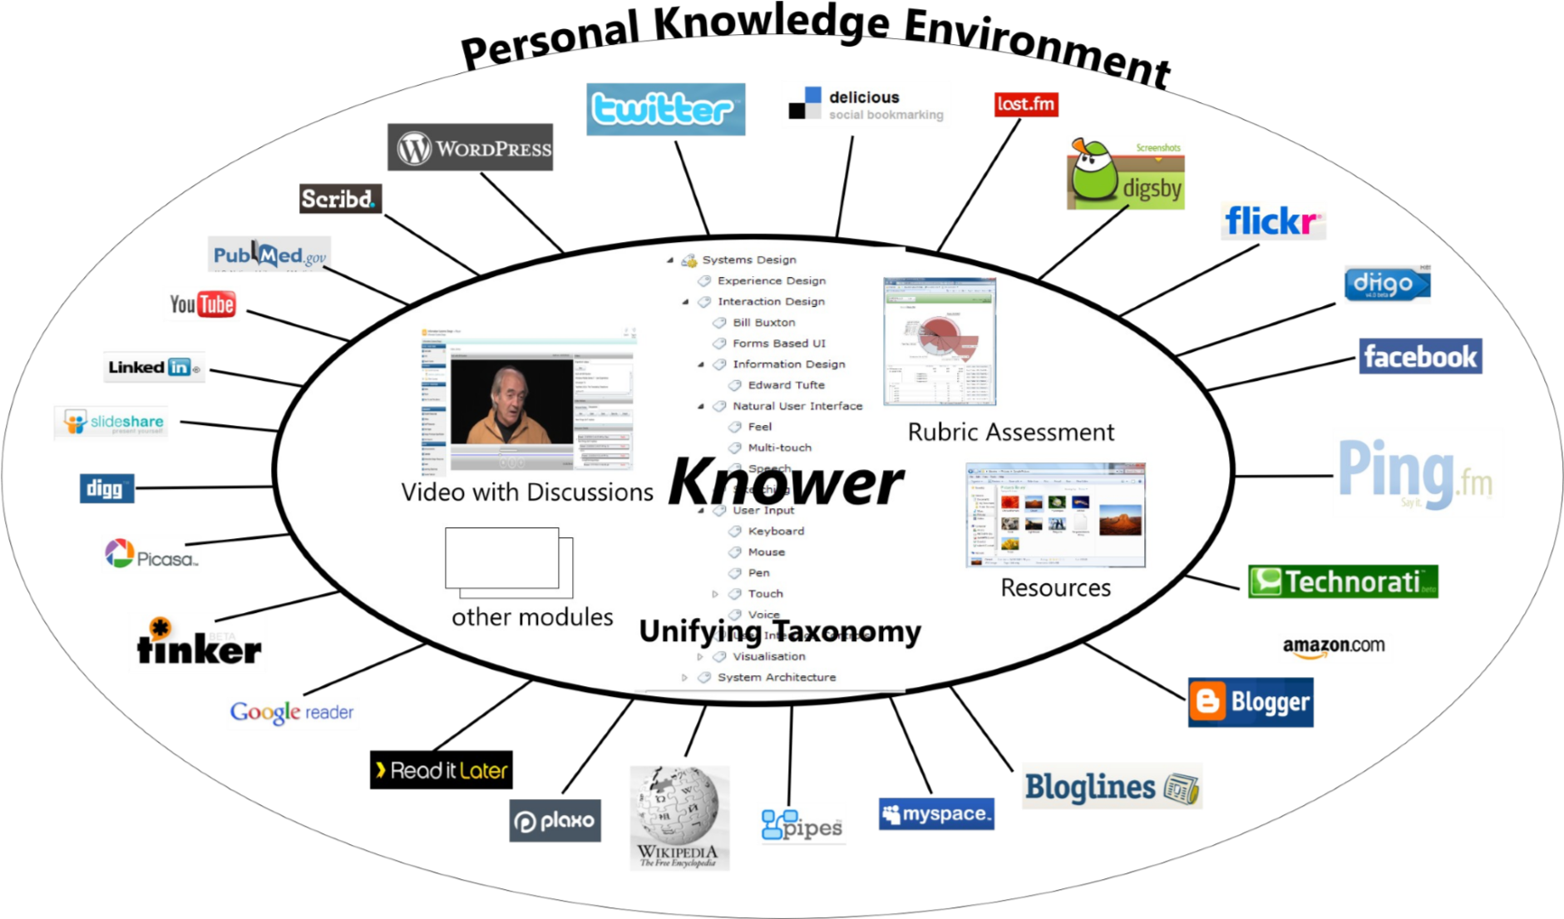
Fig. 2 A Personal Knowledge Integrator in the context of a PKE

3. What then is a Knower?
A Knower could certainly be described as a mash-up and has been by Clayton
Costa [edtechpost 2008-2009]. As I have said above, in the PLE diagrams data
flows up and down the spokes from data sources and sinks, in and out of the hub. The service a Knower can provide is to connect, coordinate and present this diverse data which may then be said to be better coalesced into knowledge in our minds. A Knower’s aim is to increase the value of the information wealth available but not generally digestible through context and cross-reference. A Knower will consist of 3 elements interfaces (pipes) to data sources and sinks, a data store/cache and, of course, a user interface.
3.1 A Knower’s Data Interfaces
These will be primarily RSS feeds, API’s and Web Services connecting to data sources and sinks. Modules of this type will allow the user to plug into many common services such as learning management systems, Flickr, WordPress, Google, Windows Live and delicious amongst many others. Also it is in a Knower that it is possible to unify and federate a number of learning management systems.
The data sources and sinks shown in Fig. 2 are in the main web pages which may or may not provide data feeds.
3.1.1 “Real” Data Feeds
From a knowledge integration perspective we move to another level of potential when we consider that we have access to an exponentially increasing amount of “real” data via sources utilizing standards such as ODATA [ODATA]. Instead of consuming data embodied in textural pages, we will/are consuming data streams. Let me illustrate this with an example.
At present I am reading, as a reader of science, an article which presents evidence about the differing rates of the emergence of new species both geographically and over time. Mention is made of the geological eras Cenozoic, Mesozoic etc. Because my knowledge of these is sketchy, to say the least I have to go and consult another source and then put the two together. Soon we will have access to the raw data about these events and will be able to merge the “new” data from the article I am reading with data from other sources to produce insightful visualisations. Already In my Knower data may be stored from a previous study of tectonic plate movement. Thus, as new knowledge is acquired it can be shown beside previous knowledge enhancing, through context, known and potential relationships.
This shift from a page to a data focus will allow the emergence of whole new dimensions of knowledge expression (data mash-ups) including visualisations, animations and simulations.
3.2 Knower Data Store
The data store design is the core element of a Knower where standardization must be considered to allow interoperability between different instances of Knowers. In all the work over the years on standards for learning management systems, learning objects etc., much is known about the requirements to support teaching, learning and knowledge management which should followed in the import and export of data. It is important that this data can be synchronised across Knowers and devices.
3.2.1 Knower Taxonomy
A very key element of the data is the essential spine of a Knower – the taxonomy and its more informal relative the folksonomy. From the beginning of the design of Cecil, taxonomy (bodies of knowledge) [Gardner, L., 2002] was at the core of the system allowing classification, and hence cross-reference of all elements such as activities, resources, quizzes, questions etc. In Cecil 2010 extensive use is being made of the SharePoint 2010 functionality of Term Stores which will be used to coordinate classification across subject areas, faculties and departments.
A person’s taxonomy can be derived in part from and will be synchronised with existing data such as categories of favourites, folders of emails and disk directories. Also in the future use will be made of search and text analysis to augment and weave taxonomies through resources. Each person’s individual collection of taxonomic terms represents their fingerprint of knowledge. As we create and extend our personal taxonomies, we will be able to share them with others. 3.3 Knower User Interface
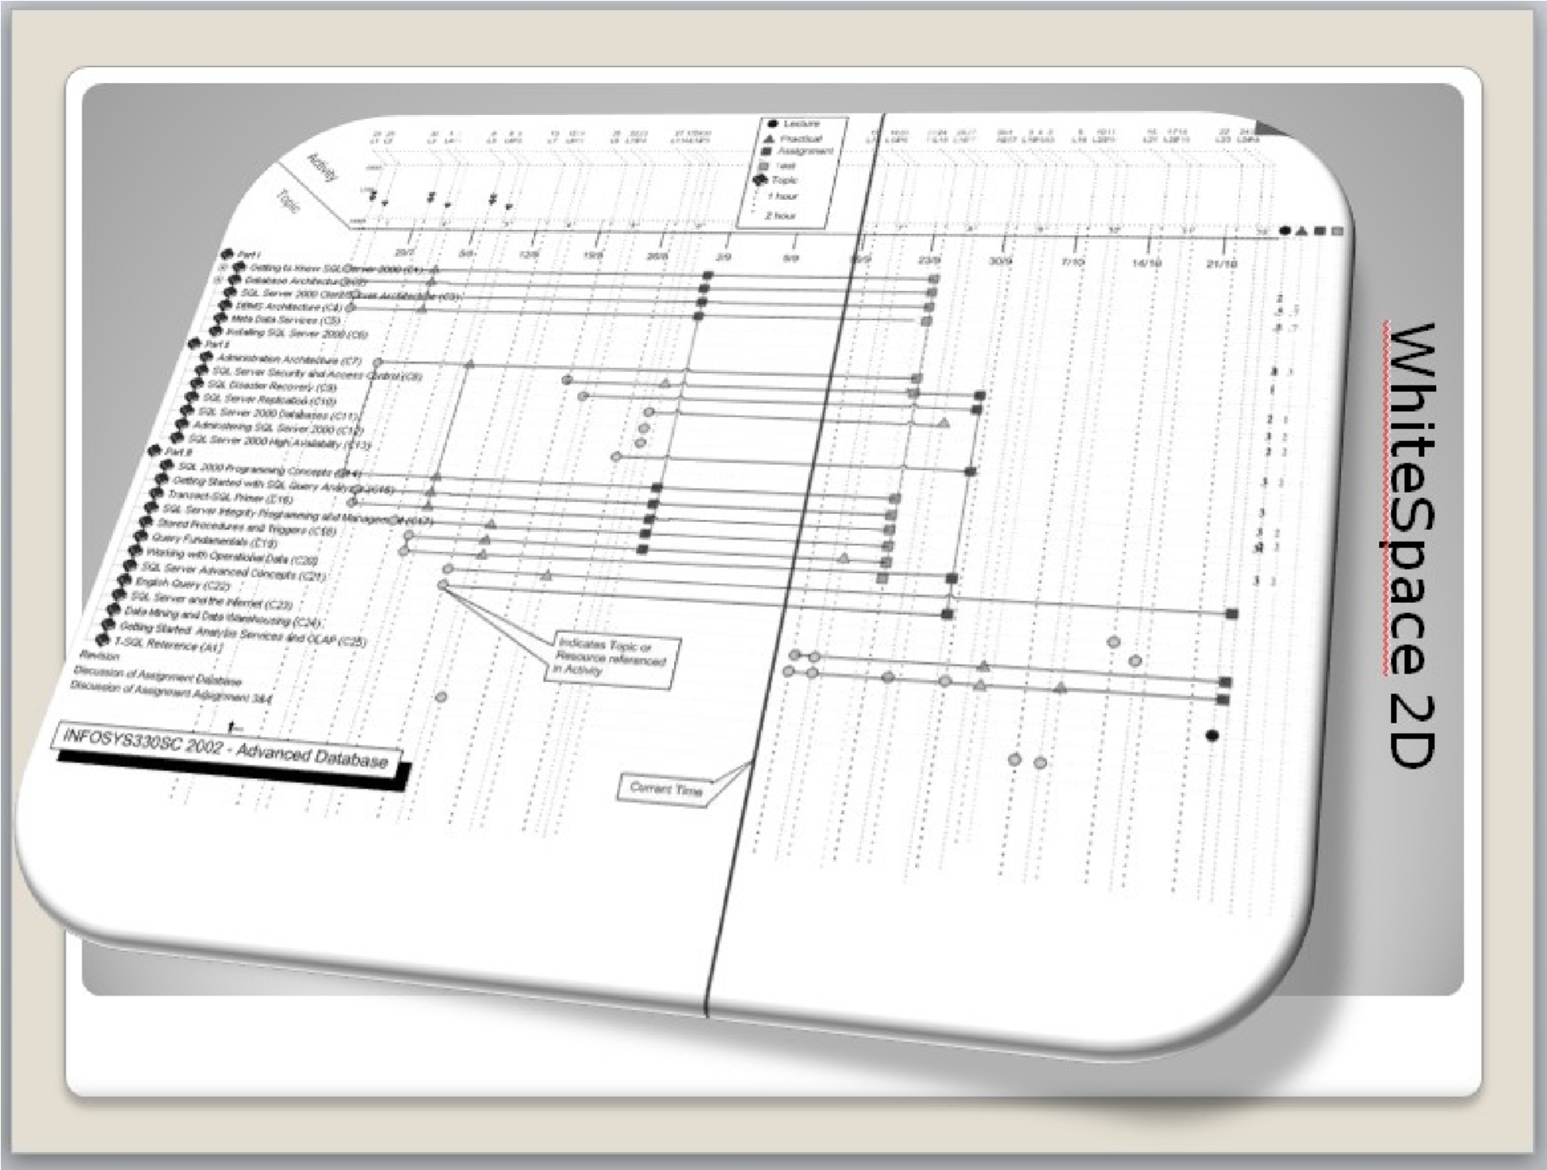
Fig. 3 WhiteSpace 2D a Projection of Taxonomic Elements vs Activities
The user interface is where we should see the maximum variety and innovation thus it is essential that the software architecture be modular and flexible. Many projections of Knower data are possible one of which “Whitespace” has already been prototyped (Fig. 3). Work on projections into 3D is on-going.

4. Noah – An instance of a Knower
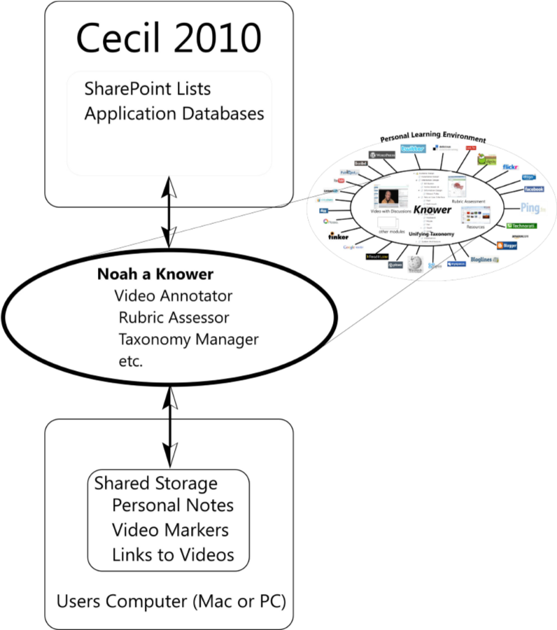
Fig. 4 Noah, an instance of a Knower, or a Personal Knowledge Integrator
Noah, the Knower being built at the University of Auckland utilises the Microsoft Rich Internet Application browser plugin, Silverlight, to create an application that can be used on PC’s, Mac’s and Linux systems (to some extent) using both in and out of browser and on and off line functionality.
4.1 Examples of Noah modules 4.1.1 Taxonomy
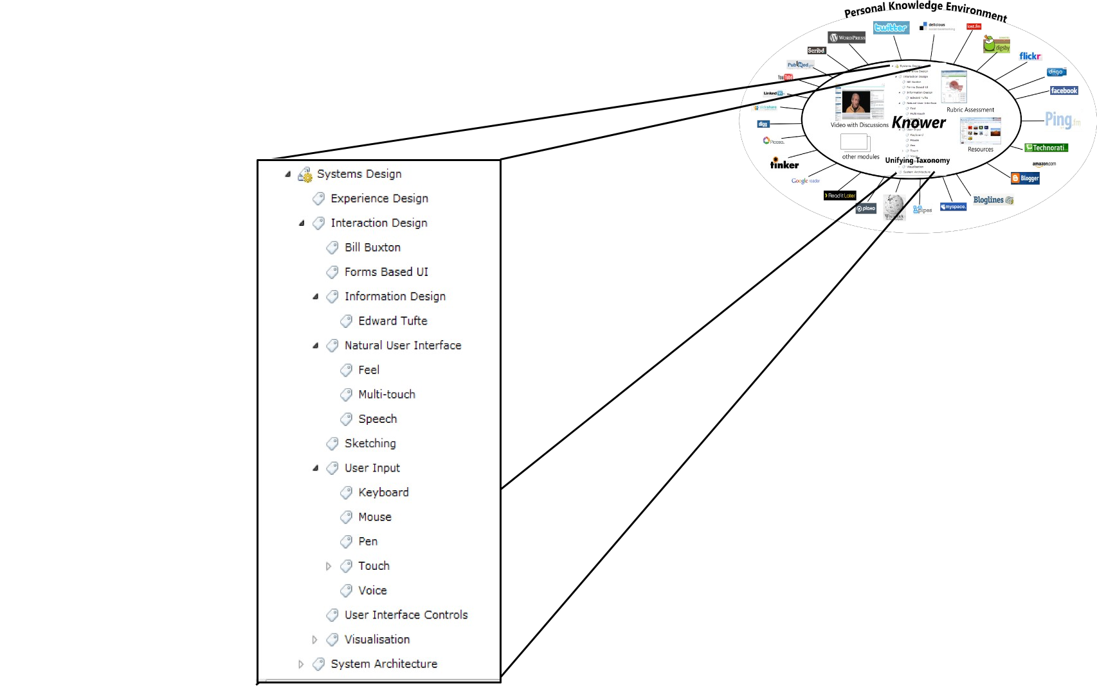
Fig. 5 Taxonomy Module of Noah
The taxonomy of a subject is the “spine” of any teaching and learning process. The more that the markers on the timeline of the Video Annotator and rubrics of the Rubric Assessor can be directly related to the subject area taxonomy, the more useful will each of these modules be. The initial taxonomy for Noah in a given discipline will be provided from Cecil:2010 using SharePoint Term Sets which in their turn provide the “spine” of a course by which all resources, activities etc. are classified. Taxonomies are available commercially and in the public domain describing many subject areas. The most general taxonomy of all is our language which is available via WordNet [WordNet] and it is planned to integrate this.
“Knowledge was once an internal property of a person, and focus on the task at hand could be imposed externally but with the Internet, knowledge can be supplied externally but focus must be forced internally” [Stanger, L. 2010] 4.1.2 Video Annotator
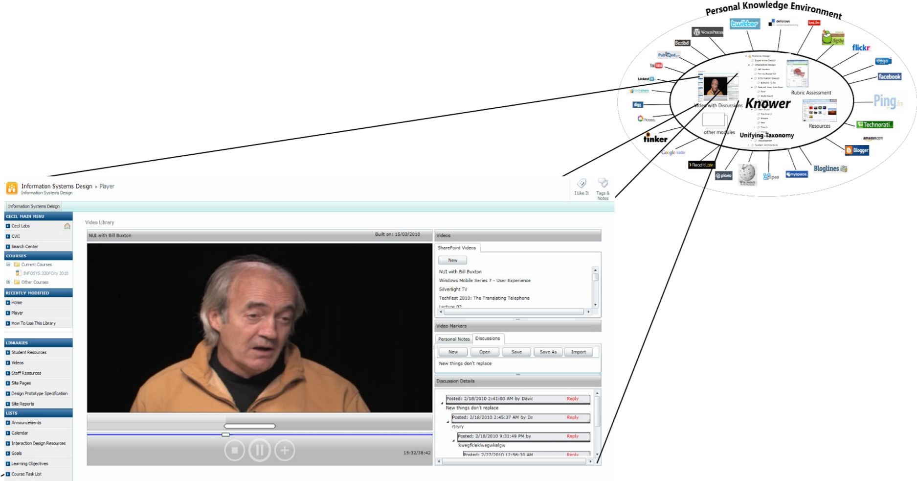
Fig. 6 Video Annotator Module of Noah
The Video Annotator (Fig. 6) is the first module of Noah which allows people to annotate videos for both personal and public use. Annotations are made by clicking the “+” button which places a marker (icon) at the video’s current position on the timeline. When annotated videos are linked to an online discussion, a public marker is placed on a discussion thread which is then displayed when the video plays or the marker selected on the timeline.
The user can work while connected or disconnected from Cecil:2010 as well as when disconnected from the internet. This means the video player can be used as a stand-alone application (Fig. 6), just like any disconnected desktop application or it can be connected to a SharePoint site to make use of any SharePoint functionality, such as when discussion threads are utilized.
While disconnected the user can open local video files as well as create and save files containing both the discussion and personal note markers. The import option allows users to import markers from one or more files and then save the imported markers as a single marker file. Exporting is basically a “save” but with the added option of choosing the marker types to export.
A very useful piece of functionality is the ability to play local video files while being connected to SharePoint. This means the user can download a large video file at university and then open the file locally while at home. If students have connected to SharePoint then the discussion markers (and their replies) for that video will be loaded. In terms of user experience, there is a significant improvement in system response time. Also the load on the video file servers is reduced. This is important because it makes the service accessible to a much larger audience rather than being limited to people working within the university’s high speed network. Watching local videos means that bandwidth is no longer an issue, even for dial-up users which is quite unique for an 'online' video application. It could be said that the Video Annotator is an ‘environmentally friendly hybrid’! It should be noted that New Zealand has expensive slow broadband.
This is an illustration of the coordination between a centralised collaborative knowledge management system and a Knower. The tags on the timeline would often be taxonomic elements.
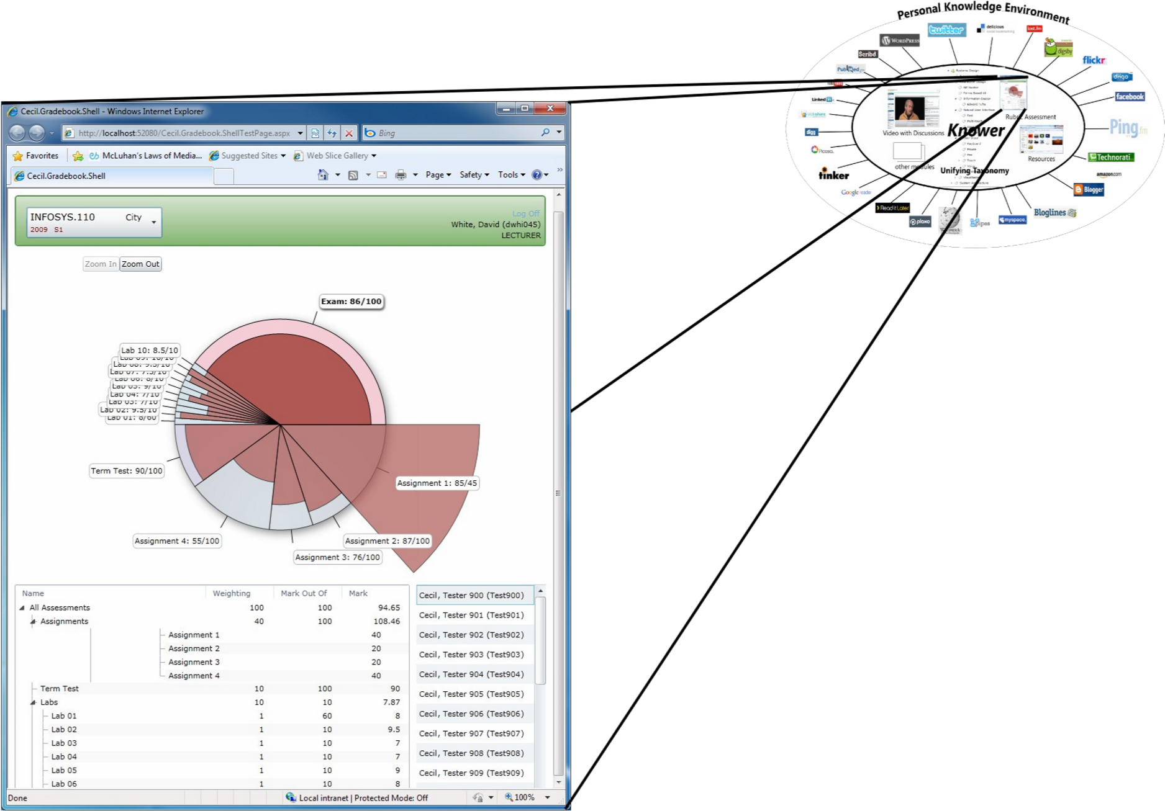
4.1.
3

Rubric Assessor
. 7 Rubric Assessor Module of Noah
At present, development is underway on another module, a Rubric Assessor. While the first focus of this was on improving feedback on a students’ work, we have adopted a more general view that will allow it to be used to assess anything from an art work to a washing machine. Indeed the integration of the rubric with the Video Annotator will allow direct assessment of video. The rubric will also be linked to the taxonomy so that taxonomic elements can be used directly in a rubric.

5. Description of the approach used
The work is being carried out by a small team of developers using the Agile methodology. Evaluation is via constant user feedback into the next design/implementation cycle.
The framework of Noah is based on the Prism Composite Application Framework for Microsoft Silverlight and the Managed Extensibility Framework (MEF). These frameworks allow for a plug-in architecture at either source code or binary level.
5.1 User/Designers
To design a spade, dig a hole. Cecil began as the design problem for a stage 3 Systems Analysis and Design class in 1995. From this class, the top 4 students were selected to build Cecil Version 1. Since that time around 60+ students have contributed to Cecil’s evolution as part-time developers and support staff in parallel with a small full-time team.
We are repeating this pattern with the design of Noah. The students of a course on
Systems Design, taught by the author, are contributing to the conceptual design of Personal Knowledge Integrators from the perspectives of both end users and designers, as part of their coursework. They are also building design prototypes. The Rubric Assessor module is being built by a group of 3 students as a work experience project.

6. Results of work done
The first module of Noah the Video Annotator has been completed and will be in use in the second semester of 2010.
It is very early to give a specific evaluation apart from reporting enthusiastic involvement of the current and potential users. More specific survey-based evaluation is planned.

7. Conclusions
There are certainly are and will be many other Knowers that people have created in response to this obvious need. It will, I am sure, be an area of fruitful development in the next few years as we learn to cope with the richness of Personal Knowledge Environments using Knowers.

8. References
Downes S., 2006, halfanhour.blogspot.com/2006/10/ple-diagram.html edtechpost 2008-2009, A Collection of PLE diagrams, edtechpost.wikispaces.com
Educause 2009, 7 things you should know about Personal Learning Environments
ELGG, elgg.org
Gardner, L., White, D., Sheridan, D., 2002, A web-based learning and assessment system to support flexible education, Journal of Computer Assisted Learning, Vol 18, No. 2, 2002, 125 - 136.
Nunamaker, J.F., Chen, M., and Purdin, T.D.M. 1991. Systems Development in Information Systems Research, Journal of Management Information Systems (7:3), pp 89-106.
ODATA, Open Data Protocol, www.odata.org/
Stanger, L. 2010 Individual Knowledge in the Internet. Educause Review March/April 2010, p.16
Uren, V., Cimiano, P., Iria, J., Handschuh, S., Vargas-Vera, M., Motta, E.,
Ciravegna ,F. 2006, Semantic annotation for knowledge management: Requirements and a survey of the state of the art, Journal of Web Semantics
WordNet, http://wordnet.princeton.edu/

